CREATE JAVA APPLICATION

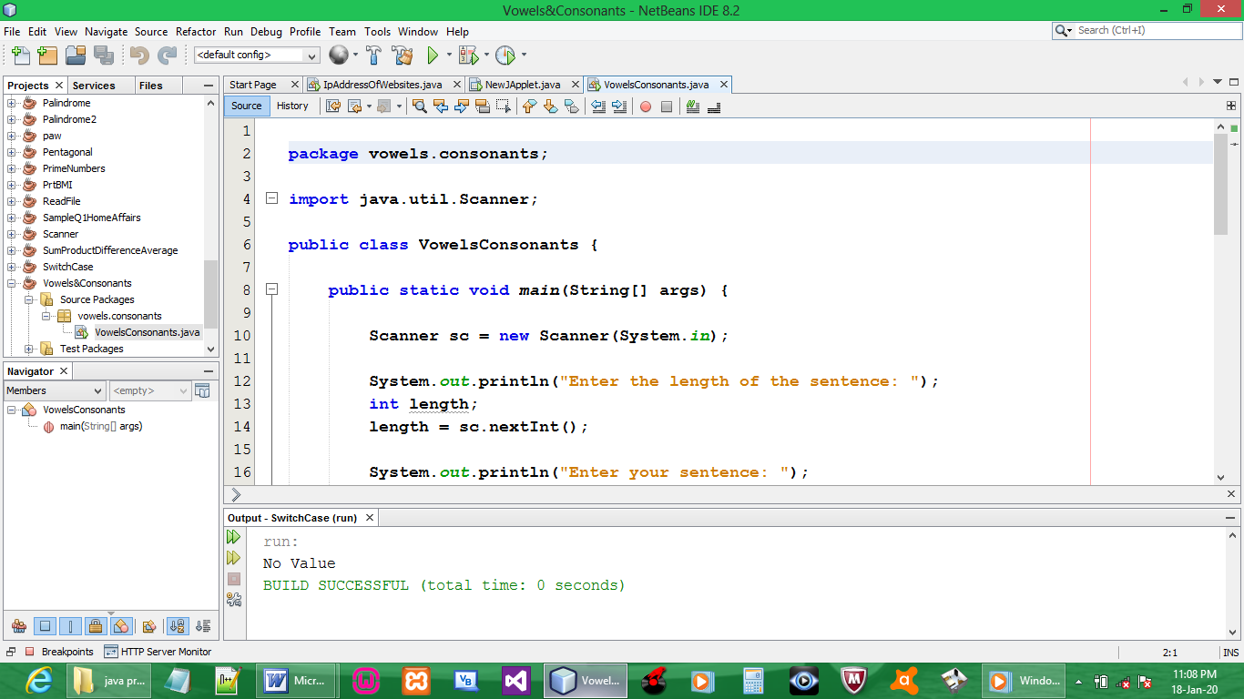

CODE:

package vowels.consonants;

import java.util.Scanner;

public class VowelsConsonants {

public static void main(String[] args) {

Scanner sc = new Scanner(System.in);

System.out.println("Enter your sentence: ");
String line;
line = sc.next();

int vowels = 0, consonants = 0, digits = 0;

line = line.toLowerCase();
for(int i = 0; i < line.length(); ++i)
{
char ch = line.charAt(i);
if(ch == 'a' || ch == 'e' || ch == 'i'
|| ch == 'o' || ch == 'u') {
++vowels;
}
else if((ch >= 'a'&& ch <= 'z')) {
++consonants;
}
else if( ch >= '0' && ch <= '9')
{
++digits;
}

}

System.out.println("Vowels: " + vowels);
System.out.println("Consonants: " + consonants);
System.out.println("Digits: " + digits);
}
}

OUTPUT:

